Order Of Service

Singing: Psalm 130—CW page 114

Reading: Psalm 97

Opening Hymn: TLH 7

Reading: Acts 18:22-28

Request Hymn: CW Supplement 748

Reading: Matthew 7:1-6

Sermon Hymn: TLH 514

Sermon Text: Mark 6:14-29

Death Of The Baptist

Prayer

The Apostles’ Creed, TLH page 12

Holy Communion

The Lord's Prayer

The Blessing

Closing Hymn: TLH 46

* * * * * * * * * * *

Bible Study: Lambs: Sun
Sheep: Proverbs 17:21-25
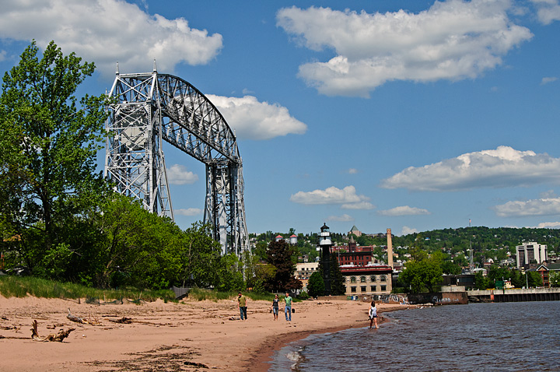

Spring In Duluth, Minnesota

Water
Of
Life

12 May 2019

W A T E R O F L I F E

Independent Christian Church—Conservative Lutheran Doctrine

Worship Service: 9:30 a.m. Bible Study: 10:45 a.m.

Larry Cooper, Pastor E-Mail address:
111 N. Ridge Road lcooper@wateroflife.cc
Coon Valley, WI 54623 Web Site:
www.wateroflife.cc

* * * * * * * * * * * * * * * * * * * * * * * * * * *

Sermon Text: Mark 6:14-29

Death Of The Baptist

* * * * * * * * * * * * * * * * * * * * * * * * * * *

Mark 6:14 And king Herod heard of him; (for his name was spread abroad:) and he said, That John the Baptist was risen from the dead, and therefore mighty works do shew forth themselves in him.
:15 Others said, That it is Elias. And others said, That it is a prophet, or as one of the prophets.
:16 But when Herod heard thereof, he said, It is John, whom I beheaded: he is risen from the dead.
:17 For Herod himself had sent forth and laid hold upon John, and bound him in prison for Herodias' sake, his brother Philip's wife: for he had married her.
:18 For John had said unto Herod, It is not lawful for thee to have thy brother's wife.
:19 Therefore Herodias had a quarrel against him, and would have killed him; but she could not:
:20 For Herod feared John, knowing that he was a just man and an holy, and observed him; and when he heard him, he did many things, and heard him gladly.
:21 And when a convenient day was come, that Herod on his birthday made a supper to his lords, high captains, and chief estates of Galilee;
:22 And when the daughter of the said Herodias came in, and danced, and pleased Herod and them that sat with him, the king said unto the damsel, Ask of me whatsoever thou wilt, and I will give it thee.
:23 And he sware unto her, Whatsoever thou shalt ask of me, I will give it thee, unto the half of my kingdom.
:24 And she went forth, and said unto her mother, What shall I ask? And she said, The head of John the Baptist.
:25 And she came in straightway with haste unto the king, and asked, saying, I will that thou give me by and by in a charger the head of John the Baptist.
:26 And the king was exceeding sorry; yet for his oath's sake, and for their sakes which sat with him, he would not reject her.
:27 And immediately the king sent an executioner, and commanded his head to be brought: and he went and beheaded him in the prison,
:28 And brought his head in a charger, and gave it to the damsel: and the damsel gave it to her mother.
:29 And when his disciples heard of it, they came and took up his corpse, and laid it in a tomb.

